**Advance Excel Assignment 6**

1. **What are the various elements of the Excel interface? Describe how they're used.**

The excel interface consists of various elements that provides user the different functionalities and features.

* 1. Ribbon: The Ribbon is horizontal strip which is located at the top of excel window and it contains multiple tabs such as File, Home, Insert, Page Layout, Formulas, Data, Review, view, help.
  2. Worksheets: Excel workbooks consist of multiple worksheets, also known as sheets. By default, a new workbook opens with a single sheet. Worksheets are displayed as tabs at the bottom of the Excel window. You can add, delete, rename, move, and copy worksheets to organize and manage data within the workbook.
  3. Cells and Grid: Cells are the individual rectangular units within a worksheet. They are identified by their column letter and row number, such as A1, B2, etc. The cells are organized in a grid-like structure, where columns are labelled with letters (A, B, C, etc.), and rows are labelled with numbers (1, 2, 3, etc.). Cells store data, formulas, and other types of information.
  4. Formula Bar: The Formula Bar is located above the worksheet grid and displays the contents of the currently selected cell. It allows you to enter, edit, and view formulas and text within cells. You can manually type formulas or use the built-in functions and references to perform calculations and manipulate data.
  5. Cell Formatting Options: Excel provides various formatting options for cells, such as font style, font size, cell borders, fill colour, number format, alignment, and more. These formatting options are available in the Ribbon's Home tab and the Format Cells dialog box. Formatting helps enhance the appearance and readability of data within cells.
  6. Status Bar: The Status Bar is located at the bottom of the Excel window. It provides information about the current status of Excel and displays various options and indicators. The Status Bar includes features like zoom level adjustment, page layout view, calculation mode, cell mode (e.g., edit or enter), and other status notifications.
  7. Quick Access Toolbar: The Quick Access Toolbar is a customizable toolbar located above the Ribbon or below the Ribbon's title bar. It contains frequently used commands and functions, such as Save, Undo, Redo, Print, etc. You can customize the toolbar by adding or removing commands based on your preferences.

1. **Write down the various applications of Excel in the industry.**

Some of the key applications of Excel in different industries include:

* 1. Financial Analysis: Excel is extensively used in finance and accounting for financial modelling, budgeting, forecasting, and analysing financial data
  2. Data Analysis and Reporting: Excel is a powerful tool for data analysis and reporting across industries and make informed decisions.
  3. Project Management: Excel is utilized in project management for tasks such as creating project plans, tracking progress, managing timelines, and resource allocation.
  4. Inventory Management: Excel is employed in inventory management to track and manage inventory levels, calculate reorder points, monitor stock movements, and generate inventory reports.
  5. Sales and Marketing: Excel is used for sales and marketing analysis, customer data management, lead tracking, sales forecasting, and campaign performance analysis.
  6. Human Resources: Excel is employed in HR departments for various tasks such as employee data management, payroll processing, attendance tracking, performance evaluation, and workforce planning.
  7. Data Visualization: Excel enables the creation of visually appealing charts, graphs, and dashboards, allowing professionals to present data in a visually compelling manner.
  8. Research and Data Collection: Excel is utilized in research and data collection processes to organize and analyse research data, perform data cleaning and transformation, and generate statistical summaries.
  9. Engineering and Manufacturing: Excel is utilized in engineering and manufacturing industries for tasks such as designing engineering models, performing calculations, analysing data, and managing production schedules.

1. **On the ribbon, make a new tab. Add some different groups, insert commands in the groups and name them according to their commands added. Copy and paste the screenshot of the steps you followed.**

The steps followed are listed in screenshot below:

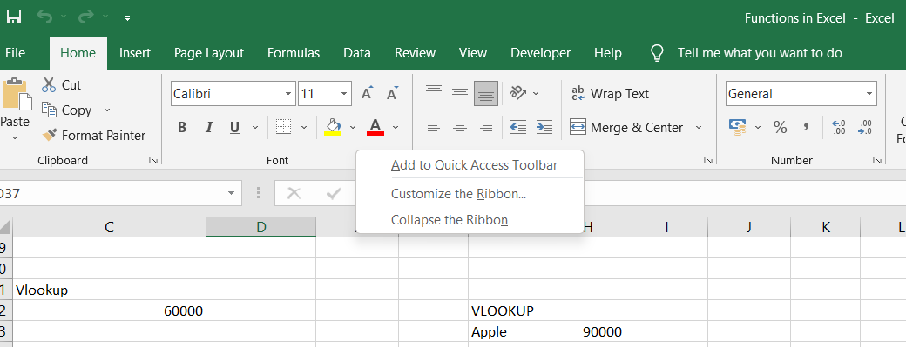

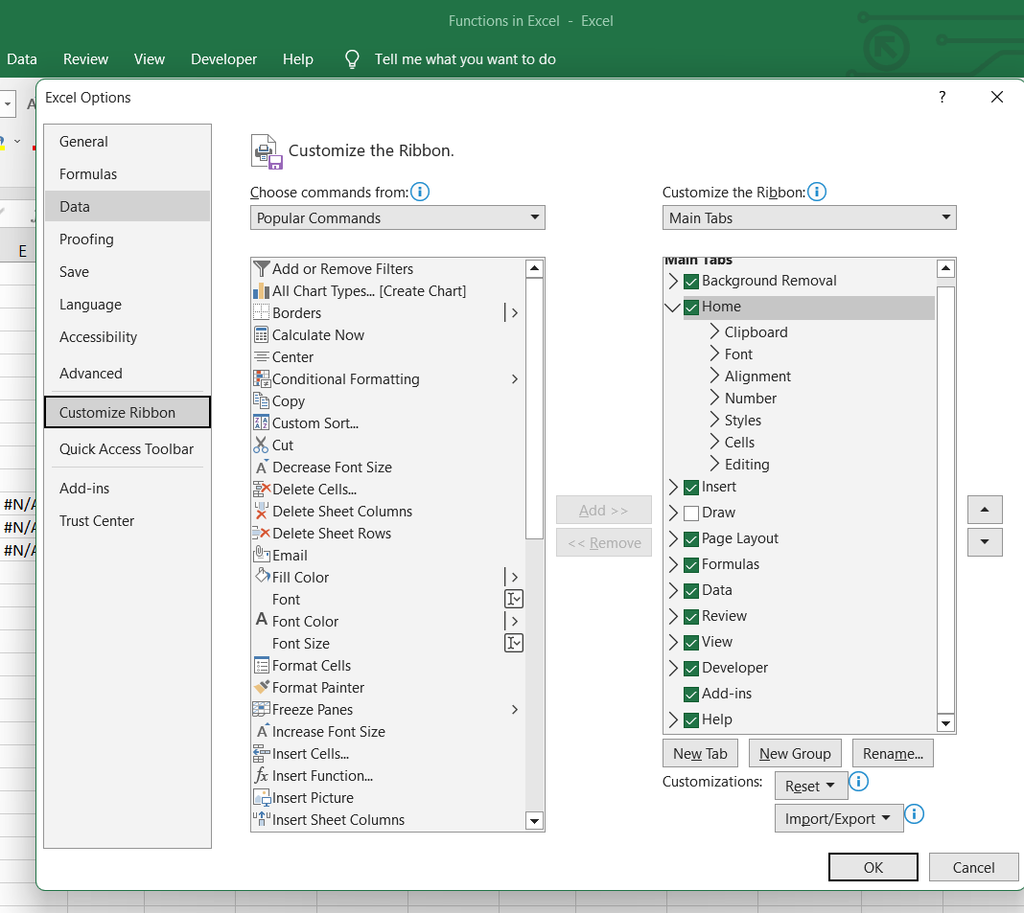

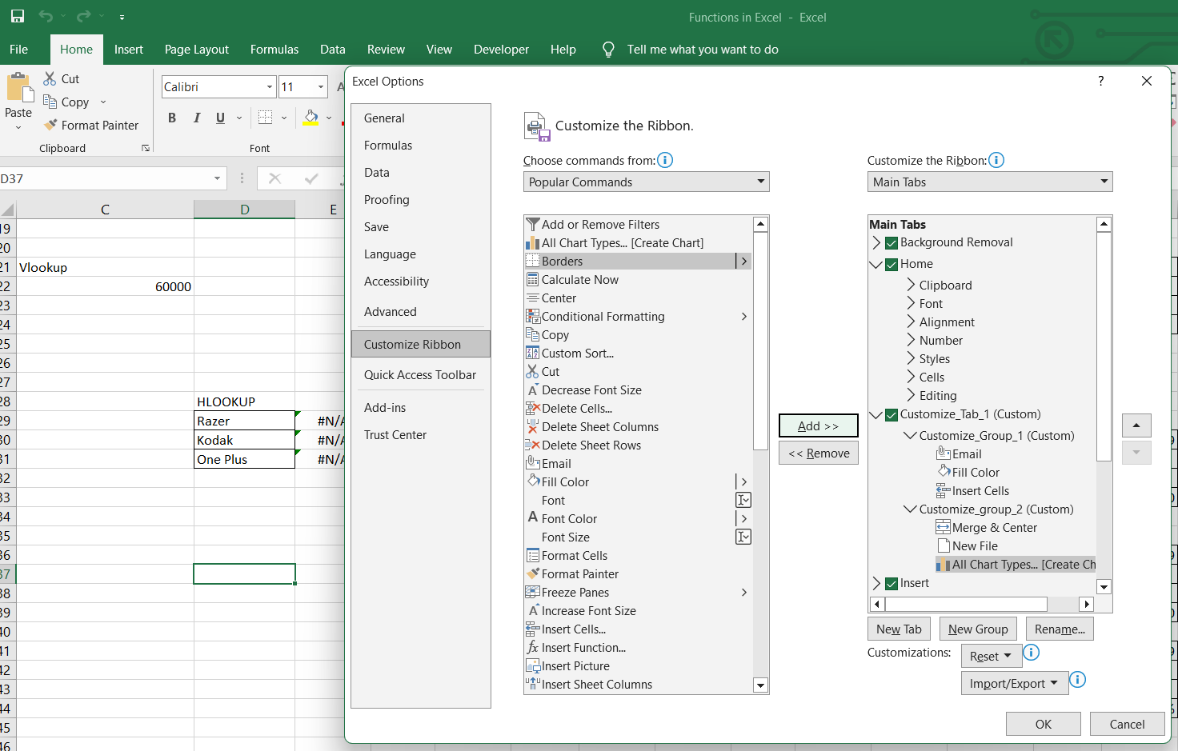

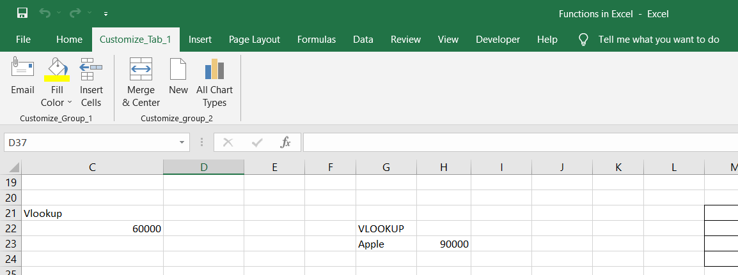

1. **Make a list of different shortcut keys that are only connected to formatting with their functions.**

Here is a list of different shortcut keys that are specifically connected to formatting in Excel and their respective functions:

1. Ctrl + B: Bold - Toggles bold formatting on or off for the selected text or cell.
2. Ctrl + I: Italic - Toggles italic formatting on or off for the selected text or cell.
3. Ctrl + U: Underline - Toggles underline formatting on or off for the selected text or cell.
4. Ctrl + 1: Format Cells - Opens the Format Cells dialog box to customize various formatting options.
5. Ctrl + Shift + $: Currency format - Applies the currency format to the selected cells.
6. Ctrl + Shift + %: Percent format - Applies the percentage format to the selected cells.
7. Ctrl + Shift + #: Date format - Applies the default date format to the selected cells.
8. Ctrl + Shift + @: Time format - Applies the default time format to the selected cells.
9. Ctrl + Shift +!: Number format - Applies the default number format to the selected cells.
10. Ctrl + Shift + &: Borders - Applies a border to the selected cells.
11. Ctrl + Shift + _: Remove Borders - Removes the border from the selected cells.
12. Ctrl + Shift + F: Font formatting - Opens the Format Cells dialog box with the Font tab selected for customizing font attributes.
13. Ctrl + Shift + P: Font size increase - Increases the font size of the selected text or cell.
14. Ctrl + Shift + M: Format as general - Removes any explicit formatting from the selected cells and applies the default "General" format.
15. Ctrl + Shift + ~: Normal number format - Applies the "General" number format to the selected cells, showing numbers as entered.
16. **What distinguishes Excel from other analytical tools?**

Excel has several distinguishing features that set it apart from other analytical tools:

1. Data Visualization: Excel provides a variety of chart types and graphing capabilities, allowing users to visually represent data in a compelling manner. It offers features for customizing charts, adding labels, legends, and other elements to enhance data visualization and presentation.
2. Integration with Other Tools: Excel seamlessly integrates with other Microsoft Office applications, such as Word and PowerPoint, allowing users to easily transfer data, reports, and analysis results between different tools. It also supports importing and exporting data from external sources, making it compatible with various file formats.
3. Collaboration and Sharing: Excel supports collaborative work, enabling multiple users to work on the same workbook simultaneously. It also provides options for sharing and distributing workbooks, including the ability to track changes, add comments, and protect sensitive information.
4. VBA Programming: Excel allows users to extend its functionality through Visual Basic for Applications (VBA) programming. With VBA, users can automate repetitive tasks, create custom functions, build interactive forms, and develop more advanced analytical solutions.

P.T.O

1. **Create a table and add a custom header and footer to your table.**

I have created table by adding customized header and footer to the table.

* Page setup > Header & Footer > Customize Header & footer > Post adding Date, Title, insert the image, Page No., File path.

